Vth = 30

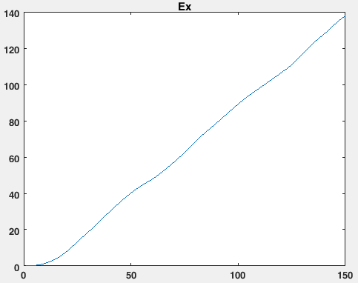

Use IF neuron, spike count = 4

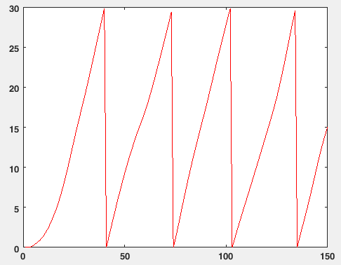

Use LIF neuron, tau = 32, Spike count = 1

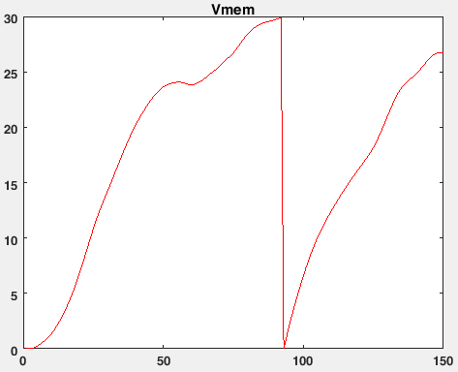

Use LIF neuron, tau = 64, Spike count = 4

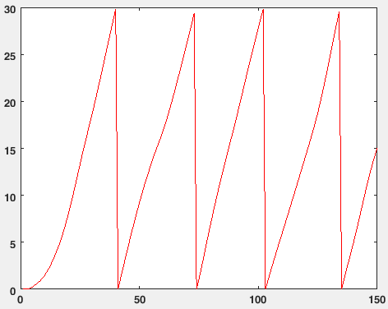

The input spike train is generated by poisson process

IF model 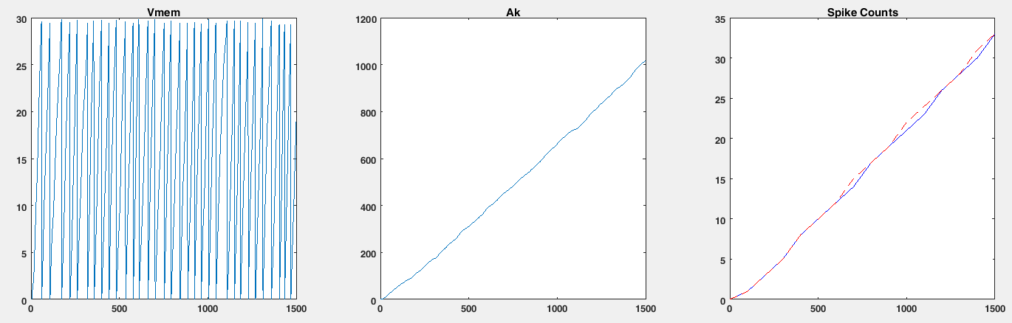

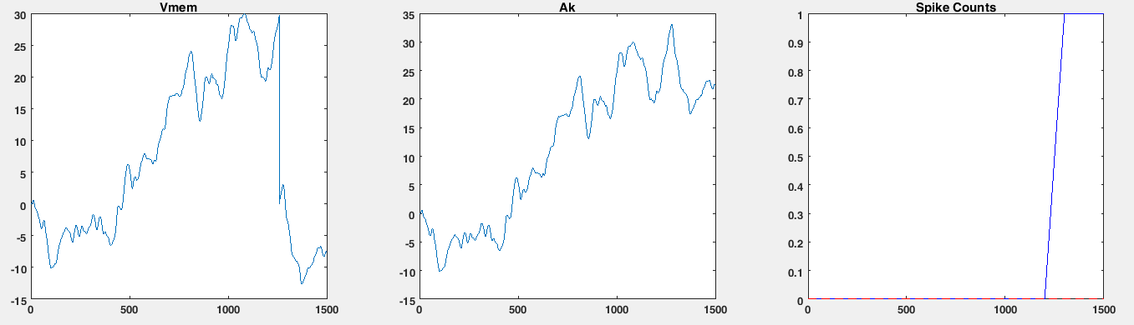

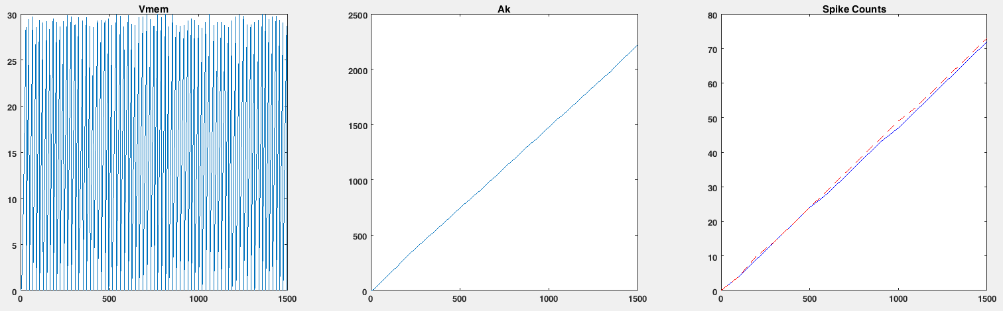

LIF model with tau = 32

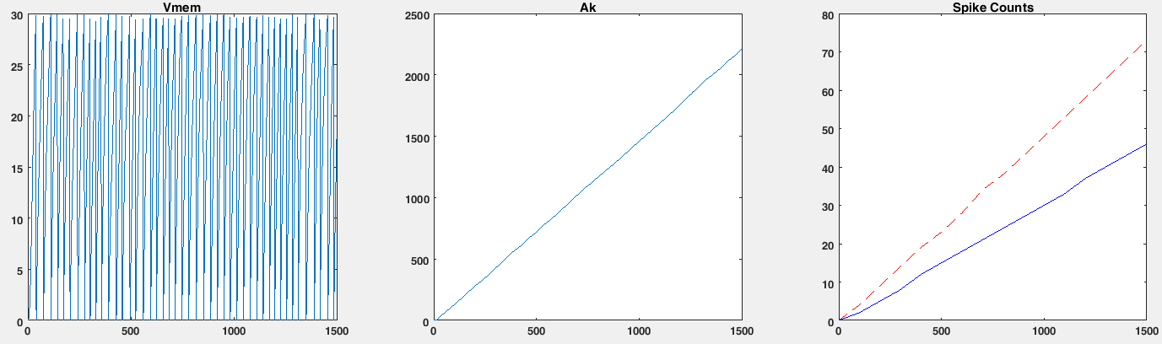

LIF model with tau = 64

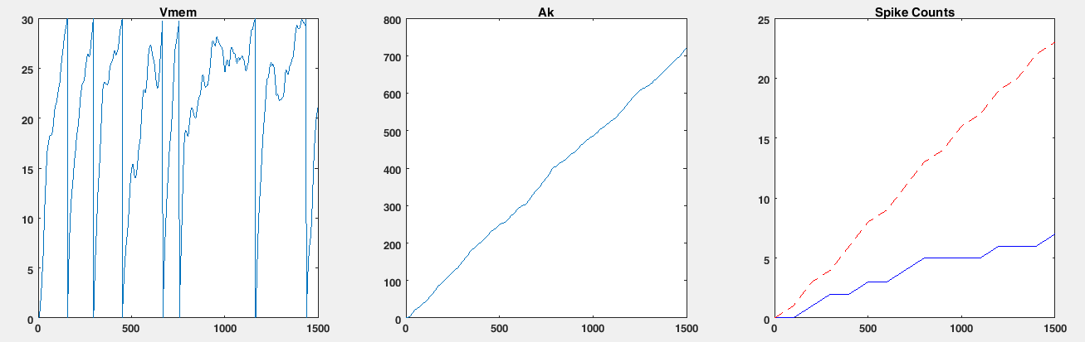

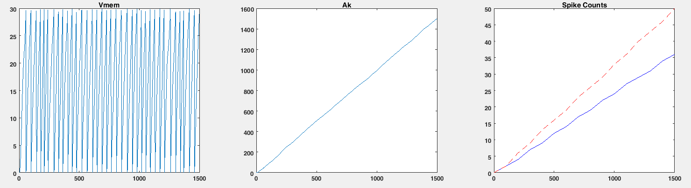

LIF model with correction

Error is small when the spike count is large:

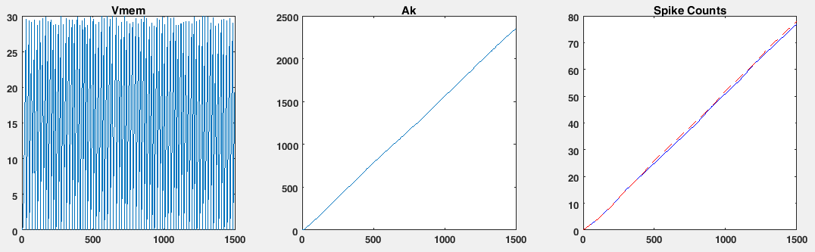

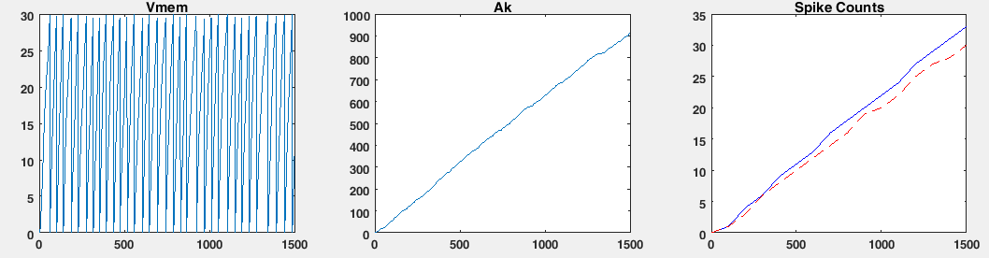

Error is large when the spike count is small

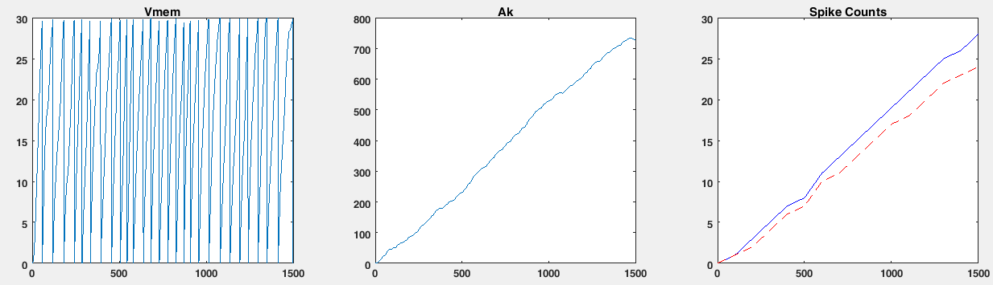

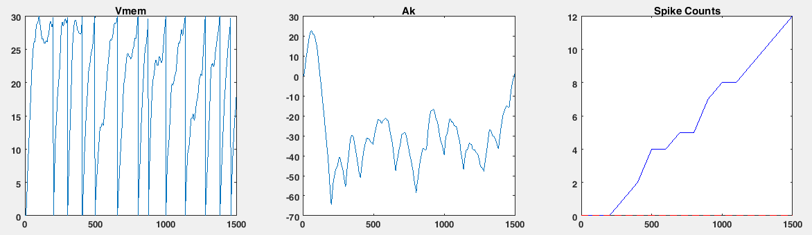

Only allow **positive weights** (0, 1)

Firing rate of the pre-synaptic neuron is from (0, 0.4)

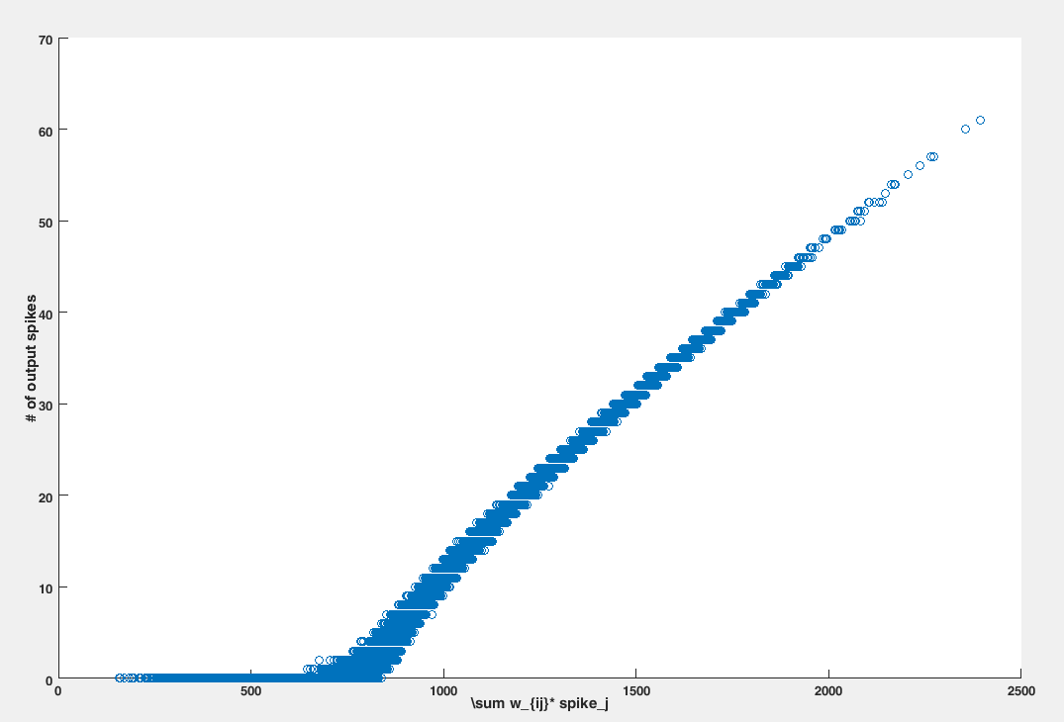

Firing rate of the pre-synaptic neuron is from (0, 1)

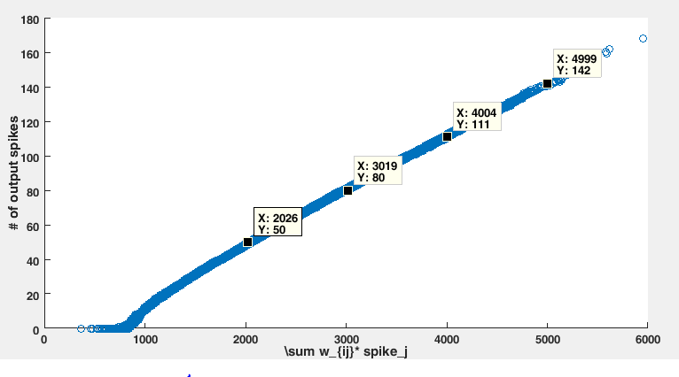

Allow both **positive and negative** weight (-1, 1):

Firing rate of the pre-synaptic neuron is from (0, 0.4):

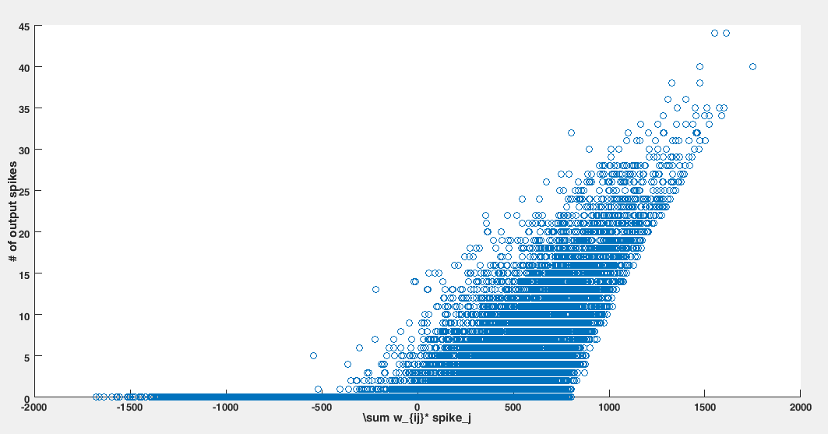

Firing rate of the pre-synaptic neuron is from (0, 1)

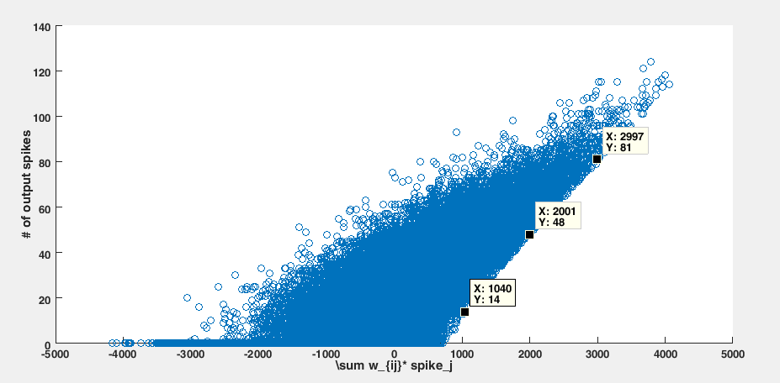

When the weight increases, we can observe a weird trend.

